Bristol Bay and Pebble Mine: An Introduction
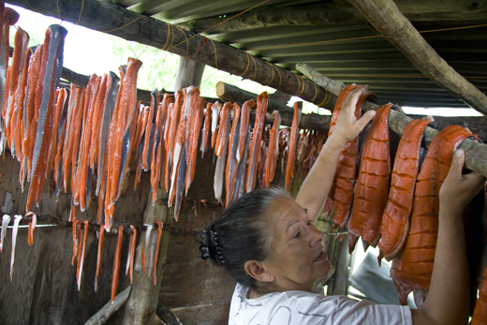
The Pebble deposit is a massive storehouse of gold, copper and molybdemum, located in the headwaters of the Kvichak and Nushagak Rivers, two of the eight major rivers that feed Bristol Bay. If built, Pebble would be one of the largest mines in the world and the largest open pit mine in North America. Because of its size, geochemistry and location, Pebble runs a high risk of polluting Bristol Bay, one of the world’s few and most productive wild salmon strongholds that supports a $500 million commercial and sport fishery. For this reason, a unique coalition include the faith community, Alaska Natives fishermen, scientists, guides, lodge owners, chefs, restaurant owners, seafood lovers, and many others to try to stop the Pebble development and to protect Bristol Bay.
Quick Facts
- The mine developers, the Pebble Limited Partnership (PLP) is made up of Northern Dynasty, a small mining company headquartered in Canada that has never developed a project of this size
- A mine of this size and scale has never been built in this type of environment.
- Preliminary designs indicate that the Pebble Mine complex would span 20 square miles of state land in the Bristol Bay watershed and would require the world’s largest earthen dam to be built, some 700 feet high and several miles in length.
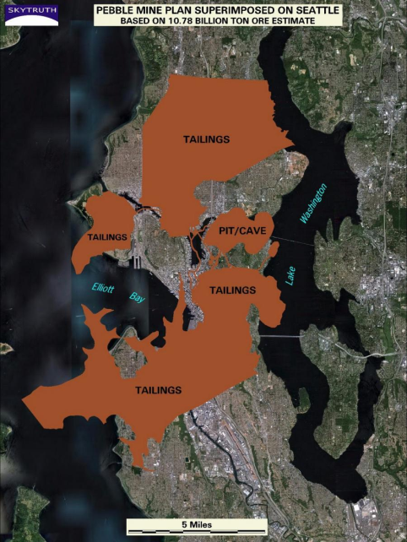
- The dam and 10-square-mile-wide containment pond are intended to hold between 2.5 billion and 10 billion tons of mine waste that Pebble would produce over its lifetime - nearly enough to bury the city of Seattle, WA.
- Because the sulfide, or acid-generating, nature of the Pebble ore body, the waste would require environmental treatment in perpetuity. Any release of mine waste into the surface or groundwater has the potential to harm Bristol Bay’s salmon runs.
- Approx. 7500 people live in Bristol Bay, the vast majority Alaskan Natives = Yupik Eskimo, Aleut, and Athabaskan the majority of whom are Orthodox Christian
- Combined, these tribal communities consumer up to 2.4 million pounds of wild salmon annually
- The value of subsistence harvesting by Alaskan Natives is worth between $77.8 and $143.1 million

