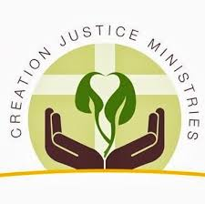
Creation Justice Ministries (CJM), formerly the Eco-Justice Program of the National Council of Churches represents, is comprised of 37 Christian denominations. CJM focuses on a wide range of environmental and justice issues that Christians are called to address. This portfolio includes climate change, energy, environmental health, food and farming, lands and wilderness stewardship, and water conservation. Concern for vulnerable populations and marginalized communities spans the issues and is of heightened importance to the work that CJM participates in.
Being located in Washington DC affords CJM the opportunity to meet with and educate the nation’s leaders and lawmakers about the faith community’s response to environmental issues. People of faith have a vital role in the various issues that are plaguing God’s planet, and CJM works as a conduit to preserve and better Creation. Partnerships with state councils of churches, interfaith groups, denominations, and individual congregations and clergy members allow for a nationwide network of faithful followers of Christ eager to better the earth for this generation and beyond.
Earth Day 2014!
The Earth Day Resource remains popular and is issued every year to be utilized by clergy and congregations around Earth Day.
The theme for the 2014 Earth Day Resource is Water, Holy Water and it will be available early next year.
Thank you for your interest in Creation Justice Ministries! If you have any questions or concerns, please feel free to contact us at info@creationjustice.org.
We would love to hear from you!

