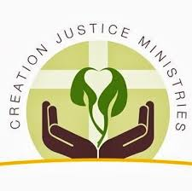
As people of faith, we are blessed to be created in the image of God and receive life-giving nourishment from Creation. Caring for our bodies, and ensuring that others are able to care for their own bodies, is one way to honor God and this gift.
Many items in our homes, our places of work, and our school include chemicals that are known to be toxic including children’s toys, furniture, and personal care products. Scientists have revealed the link between exposure to various chemicals and increasing rates of cancer, learning disabilities, and other health concerns.
We are called to care for our personal health and the health of others, particularly children, as well as the health of Creation. To this end, it is time to end our exposure to toxic chemicals and ensure that we are aware of the chemicals around us.
With the knowledge that we are burdening our bodies – these holy gifts from God – with toxic chemicals we call on our government and chemical companies to take up the following:
- Sweeping reform of government standards that oversee the use of chemicals in everyday products
- Easily accessible information regarding what chemicals are included in products readily available to consumers
- New programs that will determine the disproportionate impact toxic chemicals are having on vulnerable communities such as children, communities of color, and low-income communities

Name:______________________________________________
City, State:__________________________________________
Email:______________________________________________

Name:______________________________________________
City, State:__________________________________________
Email:______________________________________________

Name:______________________________________________
City, State:__________________________________________
Email:______________________________________________

